1. **INTRODUCTION:**

**1.1 OVERVIEW:**

**Abalones are endangered marine snails that are found in the cold costal waters worldwide, majorly being distributed of the course of New Zealand, South Africa, Australia. The price of an abalone is positively correlated to its age. However, determining the age of an abalone is highly involved process. Rings are formed in the inner shell of the abalone as it grows, usually at the rate of one ring per year. Getting access to the ring of an abalone involves cutting the shell. After polishing and staining, a lab technician examines a shell sample under a microscope and counts the rings. Because some rings are hard to make out using this method, 1.5 is traditionally added to the ring count as a reasonable approximation of the age of the abalone.**

**Due to the inherent inaccuracy in the manual method of counting the rings and thus calculating the age, researches have tried to employ physical characteristics of the abalone such as sex, weight, height and length to determine its age.**

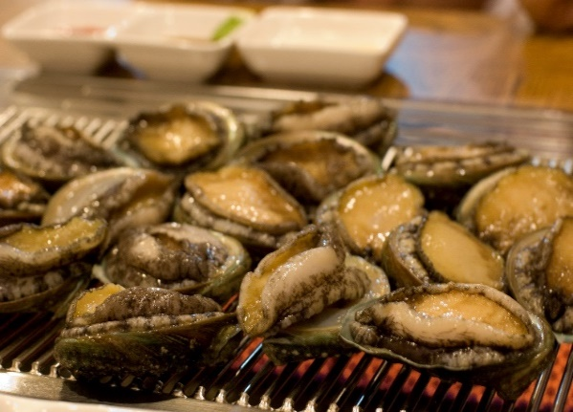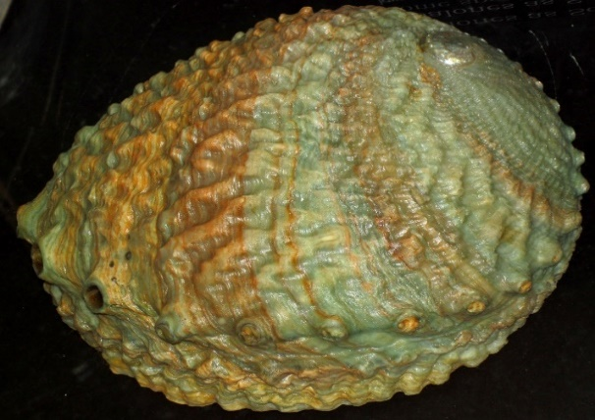

[This Photo](https://www.flickr.com/photos/jsjgeology/24200523415/) by Unknown Author is licensed under [CC BY](https://creativecommons.org/licenses/by/3.0/)

**1.2 PURPOSE:**

**Most of the research on the data set has seen the abalone age prediction problem being categorized as a classification problem that is assigning a label to each example in the data set.**

**Knowing the correct age of the abalone is important to environmentalists who seek to protect this endangered species. It helps abalone researches to understand the relation between abalones age and physical measurements. By predicting abalones age, researches can understand the environment better and protect this species.**

1. **LITERATURE** **SURVEY**:

**2.1** **EXISTING** **PROBLEM**:

* First of all, we can observe that every model’s accuracy are below 0.3, which is relatively low and hard for forecasting. This might be due to the large number of levels and the highly imbalance in our target. As we can see from the confusion matrix, a significant number of targets are predicted into adjacent categories.
* Secondly, since our goal is to predict the target ‘Rings’ to get the age of abalone, we can regard this question as regression. However, we need a constant method to compare the performance between regression models and classification models.
* Thirdly, in MLP classifier, we only worked with a small subset of all hyperparameters for shorter runtimes, with higher computing power, we can improve it by further expanding the hyperparameter search space by including other parameters of this classification method. There is similar situation in Rf classifier.

**2.1 PROPOSED SOLUTION:**

* For the imbalance dataset, we can use over sampling technique to get rid of this imbalance. However, based on the classification report and original dataset, some levels of target are extremely small, which would lose relatively in oversampling. We will consider remove some levels to get better performance.
* Another way to solve this is by regrouping the target items into different groups using binning technique. By doing this, we can keep a better balance between exactness of prediction and model accuracy.
* Since RF model slightly outperforms the other models, we can perhaps improve it by considering extra trees end other ensemble methods built on trees as potentially better models.
* We may also add AUC scores into model selection and comparison.

1. THEORITICAL ANALYSIS:
   1. **BLOCK DIAGRAM:**

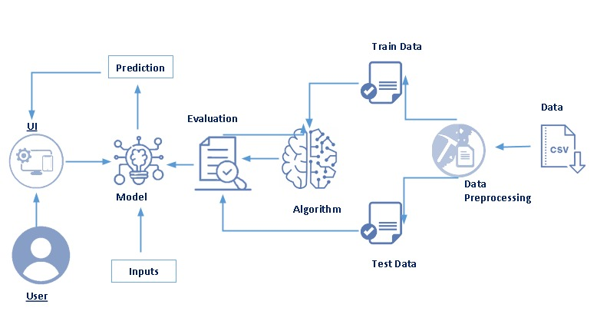

**3.2 HARDWARE/SOFTWARE DESIGNING:**

* **Used HTML,CSS,Jupyter,JavaScript for web designing.**
* **Used FLASK for integrated model and webpage in Spyder environment**

**4.EXPERIMENTAL INVESTIGATION:**

**During the project execution we experimentally found that the Application User Interface(AUI) has predefined python codes and formats to run the app.IBM cloud had inbuilt machine learning convolution neutral network and many important algorithms which the task easier and faster.**

5. FLOWCHART:

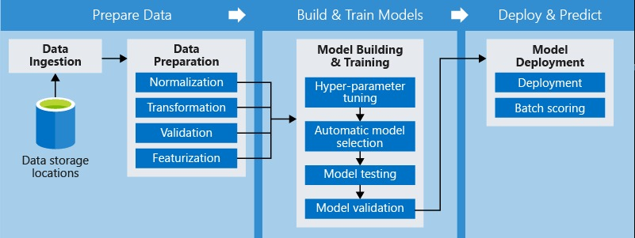

**6. Result:**

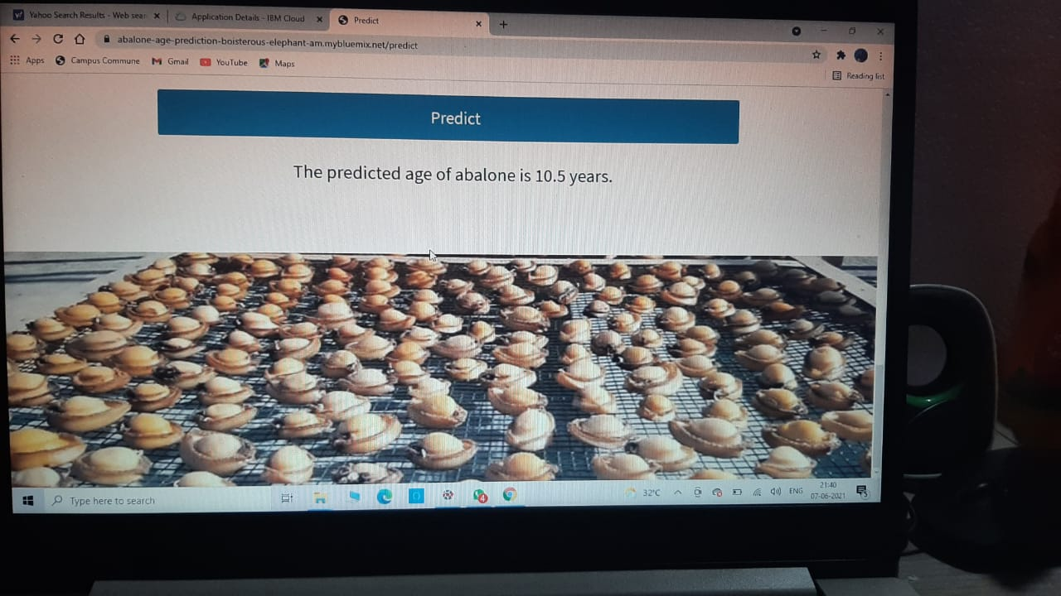

7.ADVANTAGES AND DISADVANTAGES:

**7.1** **ADVANTAGES**:

* It is salient to predict abalone age as it helps farmers and sellers to determine the market price of abalones.
* The economic value of abalone is positively correlated with their respective ages.

**7.2 DISADVANTAGES**:

* Its age can be determined by counting number of layers in its shell. This is a time-consuming process.
* We need to count the number of rings through a microscope.
* And it involves cutting of shells.

**8.** APPLICATIONS:

Knowing the correct age of the abalone is important who seek to protect this endangered species.

**9.**CONCLUSION:

On the source of this study, it appears the future regression systems effort well to forecast the age of abalone. The study directs that we do not prerequisite to count the quantity of rings consuming microscopic test. In other disputes, we do not need any laboratory experiment to predict the age of abalones. We can predict the age and price of abalone using the very simple physical individualities like weight, height, diameter, and length.

**10.FUTURE** **SCOPE**:

Its age can be determined by counting number of layers in its shell. This is a time-consuming process as it requires to cut the sample of the shell, stain it and count number of rings through a microscope. Instead, we can use the statistical approach of neutral networks to predict the age of abalone.

11.BIBLIOGRAPHY:

[1] <http://www.vada.com.au/Anatomy.html>

[2] <http://www.fish.wa.gov.au/Documents/recreational_fishing/fact_sheets/fact_sheet_abalone.pdf>

[3] <http://archive.ics.uci.edu/ml/datasets/Abalone>

APPENDIX:

1. SOURCE CODE

* PYTHON CODE

import numpy as np

import pickle

from flask import Flask,request, render_template

from gevent.pywsgi import WSGIServer

import os

app=Flask(_name_,template_folder="templates")

model = pickle.load(open('abalone.pkl', 'rb'))

@app.route('/', methods=['GET'])

def index():

return render_template('home.html')

@app.route('/home', methods=['GET'])

def about():

return render_template('home.html')

@app.route('/pred',methods=['GET'])

def page():

return render_template('upload.html')

@app.route('/predict', methods=['GET', 'POST'])

def predict():

input_features = [float(x) for x in request.form.values()]

features_value = [np.array(input_features)]

print(features_value)

features_name = ['Sex','Length','Diameter','Height','Whole weight','Shucked weight','Viscera weight','Shell weight']

prediction = model.predict(features_value)

output=prediction[0]

print(output)

return render_template('upload.html', prediction_text='The predicted age of abalone is {} years.'.format((output+1.5)))

port=os.getenv('VCAP_APP_PORT','8080')

if _name_ == '_main_':

app.secret_key=os.urandom(12)

app.run(debug=True,host='0.0.0.0',port=port)

* HTML CODE

1. <!DOCTYPE html>
2. <html lang="en">
3. <head>
4. <meta charset="UTF-8">
5. <meta name="viewport" content="width=device-width, initial-scale=1.0">
6. <title>Home</title>
7. <link rel="stylesheet" href="/static/fontawesome/css/all.min.css"> <!-- https://fontawesome.com/ -->
8. <link href="https://fonts.googleapis.com/css2?family=Source+Sans+Pro&display=swap" rel="stylesheet">
9. <!-- https://fonts.google.com/ -->
10. <link rel="stylesheet" href="/static/css/bootstrap.min.css">
11. <link rel="stylesheet" href="/static/css/templatemo-video-catalog.css">
12. <!--
13. TemplateMo 552 Video Catalog
14. https://templatemo.com/tm-552-video-catalog
15. -->
16. </head>
17. <body>
18. <div class="tm-page-wrap mx-auto">
19. <div class="position-relative">
20. <div class="potition-absolute tm-site-header">
21. <div class="container-fluid position-relative">
22. <div class="row">
23. <div class="col-5 col-md-8 ml-auto mr-0">
24. <div class="tm-site-nav">
25. <nav class="navbar navbar-expand-lg mr-0 ml-auto" id="tm-main-nav">
26. <button class="navbar-toggler tm-bg-black py-2 px-3 mr-0 ml-auto collapsed" type="button"
27. data-toggle="collapse" data-target="#navbar-nav" aria-controls="navbar-nav"
28. aria-expanded="false" aria-label="Toggle navigation">
29. <span>
30. <i class="fas fa-bars tm-menu-closed-icon"></i>
31. <i class="fas fa-times tm-menu-opened-icon"></i>
32. </span>
33. </button>
34. <div class="collapse navbar-collapse tm-nav" id="navbar-nav">
35. <ul class="navbar-nav text-uppercase">
36. <li class="nav-item active">
37. <a class="nav-link tm-nav-link" href="/home">Home<span class="sr-only">(current)</span></a>
38. </li>
39. <li class="nav-item">
40. <a class="nav-link tm-nav-link" href="/pred">Predict</a>
41. </li>
42. </ul>
43. </div>
44. </nav>
45. </div>
46. </div>
47. </div>
48. </div>
49. </div>
50. <div class="tm-welcome-container tm-fixed-header tm-fixed-header-2">
52. </div>
53. <div id="tm-fixed-header-bg"></div> <!-- Header image -->
54. </div>
55. <!-- Page content -->
56. <main>
57. <div class="container-fluid px-0">
58. <div class="mx-auto tm-content-container">
59. <div class="row mt-3 mb-5 pb-3">
60. <div class="col-12">
61. <div class="mx-auto tm-about-text-container px-3">
62. <h2 class="tm-page-title mb-4 tm-text-primary">Abalone Age Prediction</h2>
63. <p class="mb-4">Abalone is a shellfish considered a delicacy in many parts of the world. An excellent source of iron and pantothenic acid, and a nutritious food resource and farming in Australia, America and East Asia. 100 grams of abalone yields more than 20% recommended daily
64. intake of these nutrients. The economic value of abalone is positively correlated with its age. Therefore, to detect the age of abalone accurately is important for both farmers and customers to determine its price.</p>
65. <p class="mb-4">However, the current technology to decide the age is quite costly and inefficient. Farmers usually cut the shells and count the rings through microscopes to estimate the abalones age. Telling the age of abalone is therefore difficult mainly because their size
66. depends not only on their age, but on the availability of food as well. Moreover, abalone sometimes form the so-called &#39;stunted&#39; populations which have their growth characteristics very different from other abalone populations This complex method increases the cost and
67. limits its popularity. Our goal is to find out the best indicators to forecast the rings, then the age of abalone.</p>
68. </div>
69. </div>
70. </div>
71. </div>
72. <div class="parallax-window" data-parallax="scroll" data-image-src="/static/img/about-2.jpg"></div>
73. </div>
74. </main>
75. </div>
76. <script src="/static/js/jquery-3.4.1.min.js"></script>
77. <script src="/static/js/bootstrap.min.js"></script>
78. <script src="/static/js/parallax.min.js"></script>
79. </body>
80. </html>

b) [21:35, 07/06/2021] Sanjanaa@IT: <!DOCTYPE html>

<html lang="en">

<head>

<meta charset="UTF-8">

<meta name="viewport" content="width=device-width, initial-scale=1.0">

<title>Predict</title>

<link rel="stylesheet" href="/static/fontawesome/css/all.min.css"> <!-- https://fontawesome.com/ -->

<link href="https://fonts.googleapis.com/css2?family=Source+Sans+Pro&display=swap" rel="stylesheet">

<!-- https://fonts.google.com/ -->

<link rel="stylesheet" href="/static/css/bootstrap.min.css">

<link rel="stylesheet" href="/static/css/templatemo-video-catalog.css">

</head>

<!--

TemplateMo 552 Video Catalog

https://templatemo.com/tm-552-video-catalog

-->

<body>

<div class="tm-page-wrap mx-auto">

<div class="position-relative">

<div class="potition-absolute tm-site-header">

<div class="container-fluid position-relative">

<div class="row">

<div class="col-5 col-md-8 ml-auto mr-0">

<div class="tm-site-nav">

<nav class="navbar navbar-expand-lg mr-0 ml-auto" id="tm-main-nav">

<button class="navbar-toggler tm-bg-black py-2 px-3 mr-0 ml-auto collapsed" type="button"

data-toggle="collapse" data-target="#navbar-nav" aria-controls="navbar-nav"

aria-expanded="false" aria-label="Toggle navigation">

<span>

<i class="fas fa-bars tm-menu-closed-icon"></i>

<i class="fas fa-times tm-menu-opened-icon"></i>

</span>

</button>

<div class="collapse navbar-collapse tm-nav" id="navbar-nav">

<ul class="navbar-nav text-uppercase">

<li class="nav-item">

<a class="nav-link tm-nav-link" href="/home">Home</a>

</li>

<li class="nav-item active">

<a class="nav-link tm-nav-link" href="/pred">Predict<span class="sr-only">(current)</span></a>

</li>

</ul>

</div>

</nav>

</div>

</div>

</div>

</div>

</div>

<div class="tm-welcome-container tm-fixed-header tm-fixed-header-3">

</div>

<div id="tm-fixed-header-bg"></div> <!-- Header image -->

</div>

<!-- Page content -->

<main>

<center>

<div class="container-fluid px-0">

<div class="mx-auto tm-content-container">

<div class="row mt-3 mb-5 pb-3">

<div class="col-12">

<div class="mx-auto tm-about-text-container px-3">

<h2 class="tm-page-title mb-4 tm-text-primary">Enter values to predict the age of Abalone:</h2>

<form action="{{ url_for('predict')}}" method="post">

<div class="form-group">

<label for="Sex">Sex of Abalone: Enter 2 for Male, 0 for Female, 1 for Infant</label>

<input type="text" class="form-control" name="Sex" id="Sex">

</div>

<div class="form-group">

<label for="Length">Length:</label>

<input type="text" class="form-control" name="Length" id="Length">

</div>

<div class="form-group">

<label for="Diameter">Diameter:</label>

<input type="text" class="form-control" name="Diameter" id="Diameter">

</div>

<div class="form-group">

<label for="Height">Height:</label>

<input type="text" class="form-control" name="Height" id="Height">

</div>

<div class="form-group">

<label for="Whole-weight">Whole-weight:</label>

<input type="text" class="form-control" name="Whole weight" id="Whole-weight">

</div>

<div class="form-group">

<label for="Shucked-weight">Shucked-weight:</label>

<input type="text" class="form-control" name="Shucked weight" id="Shucked-weight">

</div>

<div class="form-group">

<label for="Viscera-weight">Viscera-weight:</label>

<input type="text" class="form-control" name="Viscera weight" id="Viscera-weight">

</div>

<div class="form-group">

<label for="Shell-weight">Shell-weight:</label>

<input type="text" class="form-control" name="Shell weight" id="Shell-weight">

</div>

<div class="form-group" id="submit">

<center><button type="submit" class="btn btn-primary btn-block btn-large" id="submit" value="Predict"> Predict</button></center>

</div>

<div id="output">

<h3>{{ prediction_text }}</h3>

</div>

</form>

</div>

</div>

</div>

</div>

</center>

<div class="parallax-window parallax-window-2" data-parallax="scroll" data-image-src="/static/img/contact-2.jpg"></div>

</div>

</main>

</div>

<script src="/static/js/jquery-3.4.1.min.js"></script>

<script src="/static/js/bootstrap.min.js"></script>

<script src="/static/js/parallax.min.js"></script>

</body>

</html>